Expression Tree Evaluation

**Summary:**

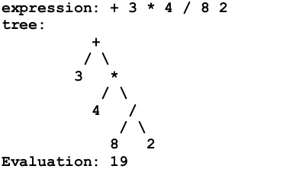The algorithm is to accept an arithmetic expression written in prefix notation then builds an expression tree for it. Then traverse to evaluate the expression. The evaluation should start after the whole expression has been entered.

The project is built using **C++, Visual Studio**.